# **1. Download the dataset: Dataset**

# **2. Load the dataset into the tool.**

In [155]:

**import** pandas **as** pd  
import numpy **as** np  
import matplotlib.pyplot **as** plt  
import seaborn **as** sns  
import plotly **as** py  
from sklearn.tree **import** DecisionTreeRegressor  
from sklearn.metrics **import** mean_absolute_error  
from sklearn.model_selection **import** train_test_split  
from sklearn.model_selection **import** cross_val_score  
from sklearn.ensemble **import** RandomForestRegressor  
#from sklearn.preprocessing.imputation import Imputer  
from xgboost **import** XGBRegressor  
from sklearn.ensemble **import** GradientBoostingRegressor, GradientBoostingClassifier  
#from sklearn.ensemble.partial_dependence import partial_dependence, plot_partial_dependence  
from sklearn.pipeline **import** make_pipeline  
from sklearn.metrics **import** confusion_matrix  
from sklearn.metrics **import** accuracy_score  
from sklearn **import** metrics  
  
data**=**pd**.**read_csv("abalone.csv")  
data

Out[155]:

|  |  |  |  |  |  |  |  |  |  |
| --- | --- | --- | --- | --- | --- | --- | --- | --- | --- |
|  | **Sex** | **Length** | **Diameter** | **Height** | **Whole weight** | **Shucked weight** | **Viscera weight** | **Shell weight** | **Rings** |
| **0** | M | 0.455 | 0.365 | 0.095 | 0.5140 | 0.2245 | 0.1010 | 0.1500 | 15 |
| **1** | M | 0.350 | 0.265 | 0.090 | 0.2255 | 0.0995 | 0.0485 | 0.0700 | 7 |
| **2** | F | 0.530 | 0.420 | 0.135 | 0.6770 | 0.2565 | 0.1415 | 0.2100 | 9 |
| **3** | M | 0.440 | 0.365 | 0.125 | 0.5160 | 0.2155 | 0.1140 | 0.1550 | 10 |
| **4** | I | 0.330 | 0.255 | 0.080 | 0.2050 | 0.0895 | 0.0395 | 0.0550 | 7 |
| **...** | ... | ... | ... | ... | ... | ... | ... | ... | ... |
| **4172** | F | 0.565 | 0.450 | 0.165 | 0.8870 | 0.3700 | 0.2390 | 0.2490 | 11 |
| **4173** | M | 0.590 | 0.440 | 0.135 | 0.9660 | 0.4390 | 0.2145 | 0.2605 | 10 |
| **4174** | M | 0.600 | 0.475 | 0.205 | 1.1760 | 0.5255 | 0.2875 | 0.3080 | 9 |
| **4175** | F | 0.625 | 0.485 | 0.150 | 1.0945 | 0.5310 | 0.2610 | 0.2960 | 10 |
| **4176** | M | 0.710 | 0.555 | 0.195 | 1.9485 | 0.9455 | 0.3765 | 0.4950 | 12 |

4177 rows × 9 columns

In [156]:

data**.**describe()

Out[156]:

|  |  |  |  |  |  |  |  |  |
| --- | --- | --- | --- | --- | --- | --- | --- | --- |
|  | **Length** | **Diameter** | **Height** | **Whole weight** | **Shucked weight** | **Viscera weight** | **Shell weight** | **Rings** |
| **count** | 4177.000000 | 4177.000000 | 4177.000000 | 4177.000000 | 4177.000000 | 4177.000000 | 4177.000000 | 4177.000000 |
| **mean** | 0.523992 | 0.407881 | 0.139516 | 0.828742 | 0.359367 | 0.180594 | 0.238831 | 9.933684 |
| **std** | 0.120093 | 0.099240 | 0.041827 | 0.490389 | 0.221963 | 0.109614 | 0.139203 | 3.224169 |
| **min** | 0.075000 | 0.055000 | 0.000000 | 0.002000 | 0.001000 | 0.000500 | 0.001500 | 1.000000 |
| **25%** | 0.450000 | 0.350000 | 0.115000 | 0.441500 | 0.186000 | 0.093500 | 0.130000 | 8.000000 |
| **50%** | 0.545000 | 0.425000 | 0.140000 | 0.799500 | 0.336000 | 0.171000 | 0.234000 | 9.000000 |
| **75%** | 0.615000 | 0.480000 | 0.165000 | 1.153000 | 0.502000 | 0.253000 | 0.329000 | 11.000000 |
| **max** | 0.815000 | 0.650000 | 1.130000 | 2.825500 | 1.488000 | 0.760000 | 1.005000 | 29.000000 |

# 3. Perform Below Visualizations.

Univariate Analysis

In [157]:

rows **=** 2  
cols **=** 2  
i **=** 0  
  
plt**.**figure(figsize**=**(cols **\*** 5, rows **\*** 5))  
  
i **+=** 1  
plt**.**subplot(rows, cols, i)  
plt**.**xticks(range(0, 31, 4))  
plt**.**xlim(0, 30)  
_ **=** sns**.**distplot(data['Rings'], kde**=False**, bins**=**range(0, 31, 2))  
  
i **+=** 1  
plt**.**subplot(rows, cols, i)  
_ **=** sns**.**distplot(data['Rings'])  
  
i **+=** 1  
plt**.**subplot(rows, cols, i)  
plt**.**xticks(range(0, 31, 4))  
plt**.**xlim(0, 30)  
_ **=** sns**.**boxplot(data['Rings'])

/usr/local/lib/python3.7/dist-packages/seaborn/distributions.py:2619: FutureWarning: `distplot` is a deprecated function and will be removed in a future version. Please adapt your code to use either `displot` (a figure-level function with similar flexibility) or `histplot` (an axes-level function for histograms).  
 warnings.warn(msg, FutureWarning)  
/usr/local/lib/python3.7/dist-packages/seaborn/_decorators.py:43: FutureWarning: Pass the following variable as a keyword arg: x. From version 0.12, the only valid positional argument will be `data`, and passing other arguments without an explicit keyword will result in an error or misinterpretation.  
 FutureWarning

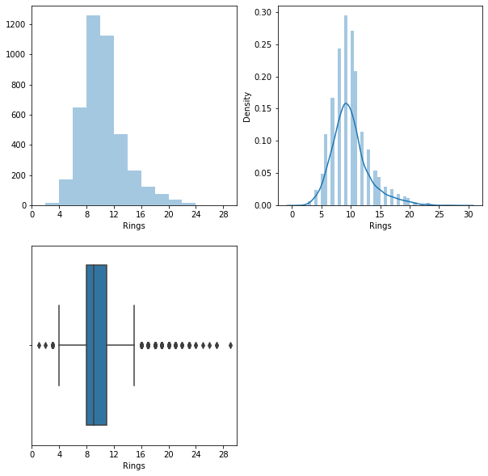

Bi - Variate Analysis

In [158]:

plt**.**scatter(data**.**Rings, data**.**Height)

Out[158]:

<matplotlib.collections.PathCollection at 0x7fd586464910>

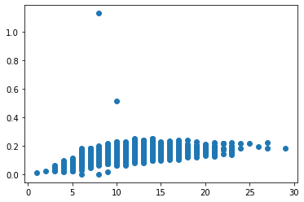

Multi-Variate Analysis

In [159]:

pd**.**plotting**.**scatter_matrix(data**.**loc[:, "Sex":"Rings"], diagonal**=**"kde",figsize**=**(20,15))  
plt**.**show()

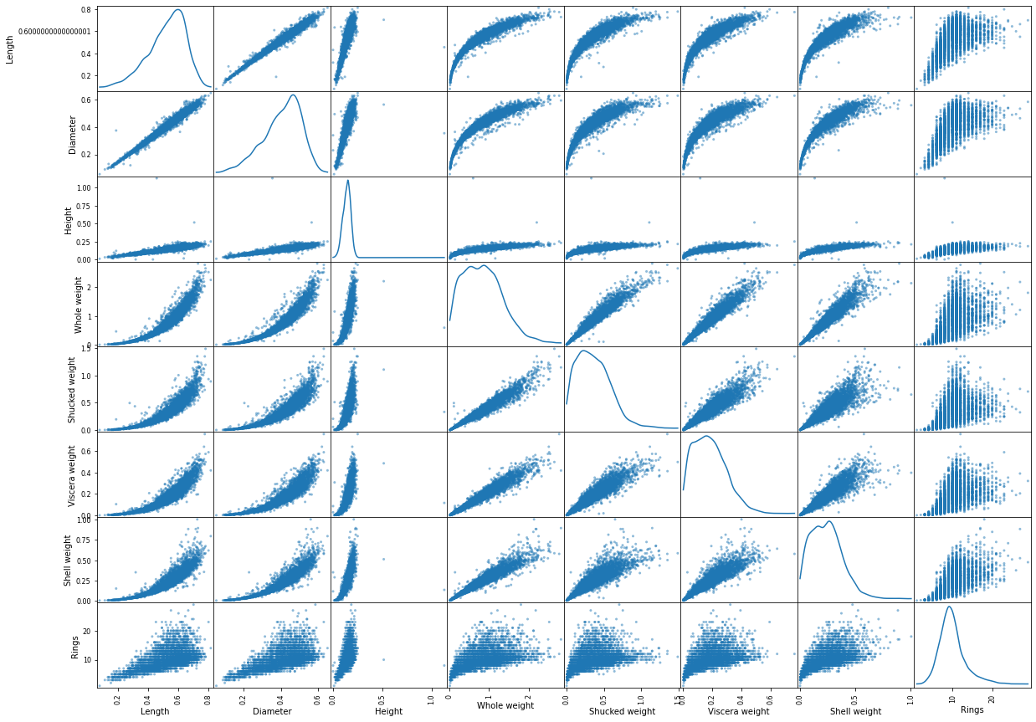

In [160]:

plt**.**figure(figsize**=**(10, 10))  
corr **=** data**.**corr()  
_ **=** sns**.**heatmap(corr, annot**=True**)

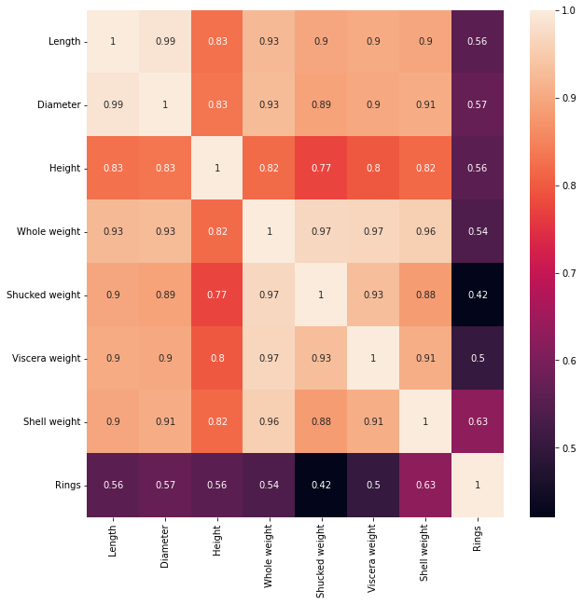

In [161]:

numerical_features **=** data**.**select_dtypes(include **=** [np**.**number])**.**columns  
categorical_features **=** data**.**select_dtypes(include **=** [np**.**object])**.**columns  
numerical_features  
categorical_features

/usr/local/lib/python3.7/dist-packages/ipykernel_launcher.py:2: DeprecationWarning: `np.object` is a deprecated alias for the builtin `object`. To silence this warning, use `object` by itself. Doing this will not modify any behavior and is safe.   
Deprecated in NumPy 1.20; for more details and guidance: <https://numpy.org/devdocs/release/1.20.0-notes.html#deprecations>

Out[161]:

Index(['Sex'], dtype='object')

In [162]:

plt**.**figure(figsize **=** (20,7))  
sns**.**heatmap(data[numerical_features]**.**corr(),annot **=** **True**)

Out[162]:

<matplotlib.axes._subplots.AxesSubplot at 0x7fd572f5f550>

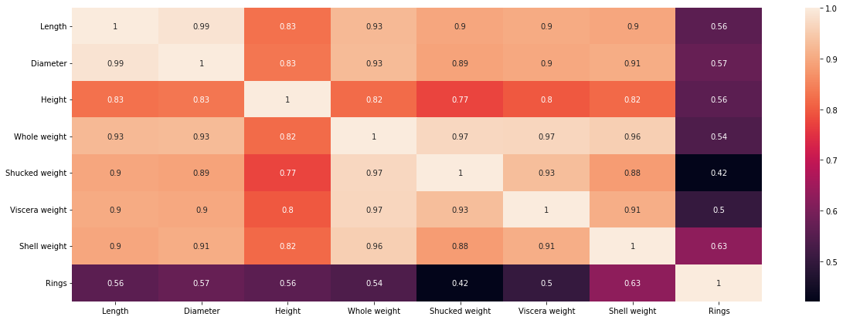

# 4. Perform descriptive statistics on the dataset.

In [163]:

data**.**columns

Out[163]:

Index(['Sex', 'Length', 'Diameter', 'Height', 'Whole weight', 'Shucked weight',  
 'Viscera weight', 'Shell weight', 'Rings'],  
 dtype='object')

In [164]:

data[['Length', 'Diameter', 'Height', 'Whole weight', 'Shucked weight','Viscera weight', 'Shell weight', 'Rings']]**.**mean()

Out[164]:

Length 0.523992  
Diameter 0.407881  
Height 0.139516  
Whole weight 0.828742  
Shucked weight 0.359367  
Viscera weight 0.180594  
Shell weight 0.238831  
Rings 9.933684  
dtype: float64

In [165]:

data[['Length', 'Diameter', 'Height', 'Whole weight', 'Shucked weight','Viscera weight', 'Shell weight', 'Rings']]**.**median()

Out[165]:

Length 0.5450  
Diameter 0.4250  
Height 0.1400  
Whole weight 0.7995  
Shucked weight 0.3360  
Viscera weight 0.1710  
Shell weight 0.2340  
Rings 9.0000  
dtype: float64

In [166]:

data[['Length', 'Diameter', 'Height', 'Whole weight', 'Shucked weight','Viscera weight', 'Shell weight', 'Rings']]**.**mode()

Out[166]:

|  |  |  |  |  |  |  |  |  |
| --- | --- | --- | --- | --- | --- | --- | --- | --- |
|  | **Length** | **Diameter** | **Height** | **Whole weight** | **Shucked weight** | **Viscera weight** | **Shell weight** | **Rings** |
| **0** | 0.550 | 0.45 | 0.15 | 0.2225 | 0.175 | 0.1715 | 0.275 | 9.0 |
| **1** | 0.625 | NaN | NaN | NaN | NaN | NaN | NaN | NaN |

In [167]:

data[['Length', 'Diameter', 'Height', 'Whole weight', 'Shucked weight','Viscera weight', 'Shell weight', 'Rings']]**.**sum()

Out[167]:

Length 2188.7150  
Diameter 1703.7200  
Height 582.7600  
Whole weight 3461.6560  
Shucked weight 1501.0780  
Viscera weight 754.3395  
Shell weight 997.5965  
Rings 41493.0000  
dtype: float64

In [168]:

data[['Length', 'Diameter', 'Height', 'Whole weight', 'Shucked weight','Viscera weight', 'Shell weight', 'Rings']]**.**quantile()

Out[168]:

Length 0.5450  
Diameter 0.4250  
Height 0.1400  
Whole weight 0.7995  
Shucked weight 0.3360  
Viscera weight 0.1710  
Shell weight 0.2340  
Rings 9.0000  
Name: 0.5, dtype: float64

In [169]:

data[['Length', 'Diameter', 'Height', 'Whole weight', 'Shucked weight','Viscera weight', 'Shell weight', 'Rings']]**.**var()

Out[169]:

Length 0.014422  
Diameter 0.009849  
Height 0.001750  
Whole weight 0.240481  
Shucked weight 0.049268  
Viscera weight 0.012015  
Shell weight 0.019377  
Rings 10.395266  
dtype: float64

In [170]:

data[['Length', 'Diameter', 'Height', 'Whole weight', 'Shucked weight','Viscera weight', 'Shell weight', 'Rings']]**.**std()

Out[170]:

Length 0.120093  
Diameter 0.099240  
Height 0.041827  
Whole weight 0.490389  
Shucked weight 0.221963  
Viscera weight 0.109614  
Shell weight 0.139203  
Rings 3.224169  
dtype: float64

In [171]:

data[['Length', 'Diameter', 'Height', 'Whole weight', 'Shucked weight','Viscera weight', 'Shell weight', 'Rings']]**.**skew()

Out[171]:

Length -0.639873  
Diameter -0.609198  
Height 3.128817  
Whole weight 0.530959  
Shucked weight 0.719098  
Viscera weight 0.591852  
Shell weight 0.620927  
Rings 1.114102  
dtype: float64

In [172]:

data[['Length', 'Diameter', 'Height', 'Whole weight', 'Shucked weight','Viscera weight', 'Shell weight', 'Rings']]**.**min()

Out[172]:

Length 0.0750  
Diameter 0.0550  
Height 0.0000  
Whole weight 0.0020  
Shucked weight 0.0010  
Viscera weight 0.0005  
Shell weight 0.0015  
Rings 1.0000  
dtype: float64

In [173]:

data[['Length', 'Diameter', 'Height', 'Whole weight', 'Shucked weight','Viscera weight', 'Shell weight', 'Rings']]**.**max()

Out[173]:

Length 0.8150  
Diameter 0.6500  
Height 1.1300  
Whole weight 2.8255  
Shucked weight 1.4880  
Viscera weight 0.7600  
Shell weight 1.0050  
Rings 29.0000  
dtype: float64

# 5. Check for Missing values and deal with them.

In [174]:

data**.**isnull()**.**sum()

Out[174]:

Sex 0  
Length 0  
Diameter 0  
Height 0  
Whole weight 0  
Shucked weight 0  
Viscera weight 0  
Shell weight 0  
Rings 0  
dtype: int64

There is no missing values

# 6. Find the outliers and replace them outliers

In [175]:

data **=** pd**.**get_dummies(data)  
dummy_data **=** data**.**copy()

In [176]:

data**.**boxplot( rot **=** 90, figsize**=**(20,5))

Out[176]:

<matplotlib.axes._subplots.AxesSubplot at 0x7fd572f4ba10>

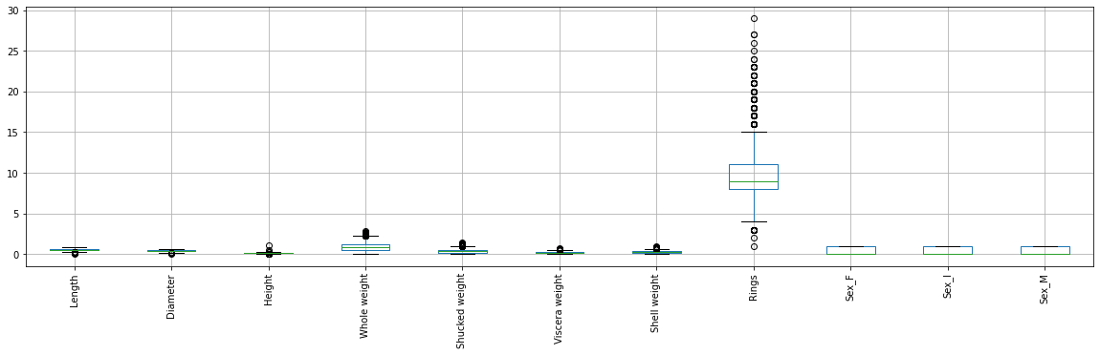

In [177]:

data['age'] **=** data['Rings']**+**1.5

In [178]:

var **=** 'Viscera weight'  
plt**.**scatter(x **=** data[var], y **=** data['age'],)  
plt**.**grid(**True**)

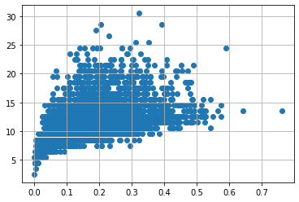

In [179]:

data**.**drop(data[(data['Viscera weight']**>** 0.5) **&** (data['age'] **<** 20)]**.**index, inplace**=True**)  
data**.**drop(data[(data['Viscera weight']**<**0.5) **&** (data['age'] **>** 25)]**.**index, inplace**=True**)

In [180]:

var **=** 'Shell weight'  
plt**.**scatter(x **=** data[var], y **=** data['age'],)  
plt**.**grid(**True**)

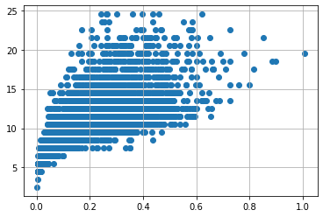

In [181]:

data**.**drop(data[(data['Shucked weight']**>=** 1) **&** (data['age'] **<** 20)]**.**index, inplace**=True**)  
data**.**drop(data[(data['Shucked weight']**<**1) **&** (data['age'] **>** 20)]**.**index, inplace**=True**)

In [182]:

var **=** 'Whole weight'  
plt**.**scatter(x **=** data[var], y **=** data['age'],)  
plt**.**grid(**True**)

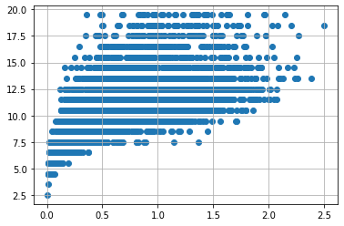

In [183]:

data**.**drop(data[(data['Whole weight']**>=** 2.5) **&** (data['age'] **<** 25)]**.**index, inplace**=True**)  
data**.**drop(data[(data['Whole weight']**<**2.5) **&** (data['age'] **>** 25)]**.**index, inplace**=True**)

In [184]:

var **=** 'Diameter'  
plt**.**scatter(x **=** data[var], y **=** data['age'],)  
plt**.**grid(**True**)

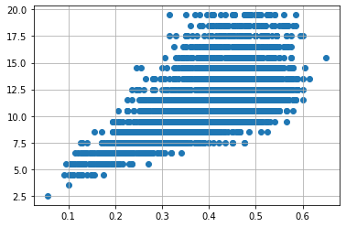

In [185]:

data**.**drop(data[(data['Diameter']**<**0.1) **&** (data['age'] **<** 5)]**.**index, inplace**=True**)  
data**.**drop(data[(data['Diameter']**<**0.6) **&** (data['age'] **>** 25)]**.**index, inplace**=True**)  
data**.**drop(data[(data['Diameter']**>=**0.6) **&** (data['age']**<** 25)]**.**index, inplace**=True**)

In [186]:

var **=** 'Height'  
plt**.**scatter(x **=** data[var], y **=** data['age'],)  
plt**.**grid(**True**)

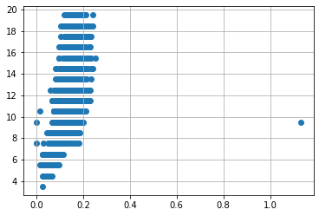

In [187]:

data**.**drop(data[(data['Height']**>**0.4) **&** (data['age'] **<** 15)]**.**index, inplace**=True**)  
data**.**drop(data[(data['Height']**<**0.4) **&** (data['age'] **>** 25)]**.**index, inplace**=True**)

In [188]:

var **=** 'Length'  
plt**.**scatter(x **=** data[var], y **=** data['age'],)  
plt**.**grid(**True**)

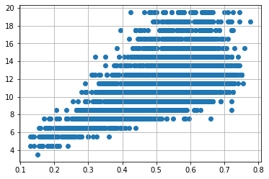

In [189]:

data**.**drop(data[(data['Length']**<**0.1) **&** (data['age'] **<** 5)]**.**index, inplace**=True**)  
data**.**drop(data[(data['Length']**<**0.8) **&** (data['age'] **>** 25)]**.**index, inplace**=True**)  
data**.**drop(data[(data['Length']**>=**0.8) **&** (data['age']**<** 25)]**.**index, inplace**=True**)

# 7. Check for Categorical columns and perform encoding.

In [190]:

**from** scipy **import** stats  
z**=** np**.**abs(stats**.**zscore(data**.**select_dtypes(include**=**[np**.**number])))  
print(z)

Length Diameter Height Whole weight Shucked weight \  
0 0.544555 0.399071 1.128902 0.620330 0.594508   
1 1.433400 1.424312 1.261866 1.247197 1.198628   
2 0.090335 0.164811 0.065193 0.266155 0.439854   
3 0.671532 0.399071 0.331120 0.615984 0.638005   
4 1.602703 1.526836 1.527793 1.291740 1.246958   
... ... ... ... ... ...   
4172 0.386616 0.472383 0.732590 0.190143 0.108688   
4173 0.598246 0.369859 0.065193 0.361798 0.442162   
4174 0.682898 0.728693 1.796299 0.818097 0.860213   
4175 0.894528 0.831217 0.333699 0.641009 0.886794   
4176 1.614069 1.548885 1.530372 2.496623 2.890056   
  
 Viscera weight Shell weight Rings Sex_F Sex_I Sex_M \  
0 0.711684 0.611842 1.908736 0.666846 0.704866 1.332557   
1 1.217824 1.221744 0.952190 0.666846 0.704866 1.332557   
2 0.321234 0.154415 0.236958 1.499596 0.704866 0.750437   
3 0.586355 0.573723 0.120657 0.666846 0.704866 1.332557   
4 1.304590 1.336101 0.952190 0.666846 1.418709 0.750437   
... ... ... ... ... ... ...   
4172 0.618738 0.142913 0.478273 1.499596 0.704866 0.750437   
4173 0.382540 0.230586 0.120657 0.666846 0.704866 1.332557   
4174 1.086314 0.592716 0.236958 0.666846 0.704866 1.332557   
4175 0.830835 0.501230 0.120657 1.499596 0.704866 0.750437   
4176 1.944341 2.018363 0.835889 0.666846 0.704866 1.332557   
  
 age   
0 1.908736   
1 0.952190   
2 0.236958   
3 0.120657   
4 0.952190   
... ...   
4172 0.478273   
4173 0.120657   
4174 0.236958   
4175 0.120657   
4176 0.835889   
  
[4022 rows x 12 columns]

In [191]:

data_o **=** data[(z **<** 3)**.**all(axis**=**1)]

In [192]:

low_cardinality_cols **=** [cname **for** cname **in** data_o**.**columns **if**  
 data_o[cname]**.**nunique() **<** 10 **and**   
 data_o[cname]**.**dtype **==** "object"]  
numeric_cols **=** [cname **for** cname **in** data_o**.**columns **if**  
 data_o[cname]**.**dtype **in** ['int64','float64']]  
  
my_cols **=** low_cardinality_cols **+** numeric_cols  
data_predictors **=** data_o[my_cols]

In [193]:

print("Shape of Abalones with outliers: "**+** str(data**.**shape) ,   
 "Shape of Abalones without outliers: " **+** str(data_o**.**shape))

Shape of Abalones with outliers: (4022, 12) Shape of Abalones without outliers: (3973, 12)

In [194]:

data_encoded_predictors **=** pd**.**get_dummies(data_predictors)

# 8. Split the data into dependent and independent variables.

In [195]:

x**=** data**.**iloc[:,3:**-**1]  
y**=**data**.**iloc[:,**-**1]  
x**.**head()

Out[195]:

|  |  |  |  |  |  |  |  |  |
| --- | --- | --- | --- | --- | --- | --- | --- | --- |
|  | **Whole weight** | **Shucked weight** | **Viscera weight** | **Shell weight** | **Rings** | **Sex_F** | **Sex_I** | **Sex_M** |
| **0** | 0.5140 | 0.2245 | 0.1010 | 0.150 | 15 | 0 | 0 | 1 |
| **1** | 0.2255 | 0.0995 | 0.0485 | 0.070 | 7 | 0 | 0 | 1 |
| **2** | 0.6770 | 0.2565 | 0.1415 | 0.210 | 9 | 1 | 0 | 0 |
| **3** | 0.5160 | 0.2155 | 0.1140 | 0.155 | 10 | 0 | 0 | 1 |
| **4** | 0.2050 | 0.0895 | 0.0395 | 0.055 | 7 | 0 | 1 | 0 |

In [196]:

x **=** data**.**iloc[:, 3:13]**.**values  
y **=** data**.**iloc[:, 3:13]**.**values

In [197]:

**from** sklearn.model_selection **import** train_test_split  
x_train, x_test, y_train, y_test **=** train_test_split(x, y, test_size **=** 0.25, random_state **=** 0)  
  
print(x_train**.**shape)  
print(y_train**.**shape)  
print(x_test**.**shape)  
print(y_test**.**shape)

(3016, 9)  
(3016, 9)  
(1006, 9)  
(1006, 9)

# 9. Scale the independent variables

In [198]:

**from** sklearn.preprocessing **import** StandardScaler  
  
sc **=** StandardScaler()  
x_train **=** sc**.**fit_transform(x_train)  
x_test **=** sc**.**fit_transform(x_test)  
  
x_train **=** pd**.**DataFrame(x_train)  
x_train**.**head()

Out[198]:

|  |  |  |  |  |  |  |  |  |  |
| --- | --- | --- | --- | --- | --- | --- | --- | --- | --- |
|  | **0** | **1** | **2** | **3** | **4** | **5** | **6** | **7** | **8** |
| **0** | -0.769217 | -0.763992 | -0.861091 | -0.660073 | 0.846424 | -0.681232 | 1.429472 | -0.740979 | 0.846424 |
| **1** | -1.469024 | -1.471684 | -1.374250 | -1.431125 | -0.236960 | -0.681232 | -0.699559 | 1.349566 | -0.236960 |
| **2** | 1.559468 | 1.118323 | 2.275953 | 1.210298 | 1.929808 | -0.681232 | -0.699559 | 1.349566 | 1.929808 |
| **3** | 1.245047 | 1.254511 | 1.399711 | 1.248469 | 0.846424 | -0.681232 | -0.699559 | 1.349566 | 0.846424 |
| **4** | 0.546332 | 0.213645 | 1.554627 | 0.408710 | 0.846424 | 1.467928 | -0.699559 | -0.740979 | 0.846424 |

# 10. Split the data into training and testing

In [199]:

train, test **=** train_test_split(data, test_size**=**0.25, random_state**=**1)  
print('Train data points :', len(train))  
print('Test data points :', len(test))

Train data points : 3016  
Test data points : 1006

In [200]:

**from** sklearn.model_selection **import** train_test_split  
x_train, x_test, y_train, y_test **=** train_test_split(x, y, test_size **=** 0.25, random_state **=** 0)  
  
print(x_train**.**shape)  
print(y_train**.**shape)  
print(x_test**.**shape)  
print(y_test**.**shape)

(3016, 9)  
(3016, 9)  
(1006, 9)  
(1006, 9)

# 11. Build the Model

In [201]:

**from** sklearn.ensemble **import** RandomForestRegressor  
  
# instantiate model  
rf **=** RandomForestRegressor(n_jobs**=-**1, *#n_jobs=-1 means that we are using all computer power to fit the model*  
 random_state**=**14)  
  
# fit the model  
rf**.**fit(x_train, y_train)

Out[201]:

RandomForestRegressor(n_jobs=-1, random_state=14)

In [202]:

**from** sklearn.linear_model **import** LinearRegression  
from sklearn.linear_model **import** Lasso  
models **=** {'linear_regression':LinearRegression(),  
   
 'lasso':Lasso(random_state**=**1),  
   
 'decision_tree':DecisionTreeRegressor(random_state**=**1),  
   
 'random_forest':RandomForestRegressor(random_state**=**1),  
   
 'xgboost':XGBRegressor(random_state**=**1),  
 }

In [203]:

rf_params **=** {'n_estimators': 200,   
 'min_samples_split': 2,  
 'min_samples_leaf': 4,   
 'max_features': 'sqrt',   
 'max_depth': **None**,   
 'bootstrap': **True**}  
  
model **=** RandomForestRegressor(random_state**=**1, **\*\***rf_params)  
  
model**.**fit(x_train, y_train)

Out[203]:

RandomForestRegressor(max_features='sqrt', min_samples_leaf=4, n_estimators=200,  
 random_state=1)

# 12. Train the Model

In [204]:

X **=** data**.**iloc[:, :**-**1]**.**values  
y **=** data**.**iloc[:, **-**1]**.**values  
train_X,val_X,train_y,val_y **=** train_test_split(X, y, test_size **=** 0.2, random_state **=** 0)

In [205]:

print("Shape of Training X :",train_X**.**shape)  
print("Shape of Validation X :",val_X**.**shape)  
print("Shape of Training y :",train_y**.**shape)  
print("Shape of Validation y :",val_y**.**shape)

Shape of Training X : (3217, 11)  
Shape of Validation X : (805, 11)  
Shape of Training y : (3217,)  
Shape of Validation y : (805,)

In [206]:

lr **=** LinearRegression()  
lr**.**fit(train_X,train_y)  
print('Attempting to fit Linear Regressor')

Attempting to fit Linear Regressor

In [207]:

**%%**time  
y_pred_val_lr **=** lr**.**predict(val_X)  
print('MAE on Validation set :',metrics**.**mean_absolute_error(val_y, y_pred_val_lr))  
print("\n")  
print('MSE on Validation set :',metrics**.**mean_squared_error(val_y, y_pred_val_lr))  
print("\n")  
print('RMSE on Validation set :',np**.**sqrt(metrics**.**mean_absolute_error(val_y, y_pred_val_lr)))  
print("\n")  
print('R2 Score on Validation set :',metrics**.**r2_score(val_y, y_pred_val_lr))  
print("\n")

MAE on Validation set : 1.1546319456101628e-15  
  
  
MSE on Validation set : 3.1821472974893545e-30  
  
  
RMSE on Validation set : 3.397987559733206e-08  
  
  
R2 Score on Validation set : 1.0  
  
  
CPU times: user 6.83 ms, sys: 4.96 ms, total: 11.8 ms  
Wall time: 12.7 ms

# 13. Test the Model

In [208]:

**import** numpy **as** np  
import numpy  
from sklearn.metrics **import** r2_score  
numpy**.**random**.**seed(2)  
x **=** numpy**.**random**.**normal(3, 1, 100)  
y **=** numpy**.**random**.**normal(150, 40, 100) **/** x  
train_x **=** x[:80]  
train_y **=** y[:80]  
  
test_x **=** x[80:]  
test_y **=** y[80:]  
  
mymodel **=** numpy**.**poly1d(numpy**.**polyfit(train_x, train_y, 4))  
  
r2 **=** r2_score(test_y, mymodel(test_x))  
  
print(r2)

0.8086921460343566

# 14. Measure the performance using Metrics.

In [209]:

**from** sklearn.metrics **import** mean_absolute_error, r2_score, mean_squared_log_error  
  
# create an evaluation function  
def show_score(model):  
 train_preds**=** model**.**predict(x_train)  
 test_preds **=** model**.**predict(x_test)  
 scores **=** {"Training MAE": mean_absolute_error(y_train, train_preds),  
 "Test MAE": mean_absolute_error(y_test, test_preds),  
 "Training MSE": mean_squared_log_error(y_train, train_preds),  
 "Test MSE": mean_squared_log_error(y_test, test_preds),  
 "Training RMSE": np**.**sqrt(mean_squared_log_error(y_train, train_preds)),  
 "Test RMSE": np**.**sqrt(mean_squared_log_error(y_test, test_preds)),  
 "Training R2": r2_score(y_train, train_preds),  
 "Test R2": r2_score(y_test, test_preds)}  
 **return** scores  
# fit

In [210]:

rf**.**fit(x_train, y_train)

Out[210]:

RandomForestRegressor(n_jobs=-1, random_state=14)

In [211]:

show_score(rf)

Out[211]:

{'Training MAE': 0.002969515362511056,  
 'Test MAE': 0.008333732052131658,  
 'Training MSE': 3.377316030763978e-05,  
 'Test MSE': 0.00022606804480543698,  
 'Training RMSE': 0.0058114679993646855,  
 'Test RMSE': 0.015035559344614919,  
 'Training R2': 0.9977286616319563,  
 'Test R2': 0.984112781560057}

In [211]: